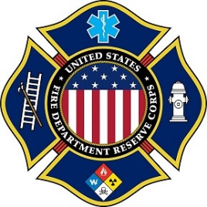 | The United States Fire Department Reserve Corps  4700 Millenia Blvd., Suite 175 Orlando, Florida 32839  Telephone: 1 (321) 332-7100  Web: www.usfdrc.org

CONTRIBUTION FORM
Your gift to the United States Fire Department Reserve Corps (US FDRC) expand our programs and offerings to the communities we serve. Each year, our organization assists individuals, often at a moment’s notice and without donations from individuals like you, this would not be possible. Donations help sustain our organization and benefit the communities we serve.
We ask that you make a commitment to support our mission. Your generosity will make a difference by allowing us to continue our work. Remember that every donation makes a difference no matter what size. Your gift is tax deductible
Please print and mail this form to us at the address below with your tax-deductible contribution made payable to the US FDRC. Thank you for your support.
Please Print

Name: ___________________________________________________________________

Address: _________________________________________________________________

City/State/Zip: ____________________________________________________________

E-mail: _____________________________ Phone: _____________________________

Yes, I am pleased to support the work of the US FDRC with a gift of:

- $ 500 or more
- $ 250
- $ 100
- $ 50
- $ 25
- Other $___

- My company will match my gift. (Form is enclosed.)
- I wish my gift to remain anonymous.
- I wish my gift to be made in honor/memory of _________________________________.
Please provide the name and address of person to be notified of your gift below:
Name: __________________________________
Address: __________________________________
__________________________________
You may also wish to make a bequest or a gift of stock. When you give long-term appreciated securities, you may pay no capital gains tax on the transfer and be entitled to an income tax charitable deduction based on the full current market value of the stock. Your tax advisor can give you specific information. The US FDRC is a 501 (c) (3) tax-exempt organization and all contributions are tax-deductible to the extent allowed by law.
Please make checks payable to: US FDRC
P.O. Box 616702
Orlando, Florida 32861-6702

